**Problem Solving**

**CA3 Individual Assignment**

**Oct 2022 Semester**

**Name: Jeslyn Ho Ka Yan:**

**ID: 10241485**

**Date of Submission: 11Nov 2022**

**Table of Content**

Report 3

Flowchart 4

User Guide 5

# Report

I designed a mini program to automate a simple arithmetic quiz for primary 1 students. This program will allow students to log in and register their user id, name, class Number, gender, and password.

After login into their account, there will be a menu section.

1. **Start Quiz,**

allow students to do 3 different types of quizzes.

**Basic,** have a total of 5 questions, only addition and subtraction will be tested

**Normal,** have a total of 8 questions, only multiplication and division will be tested.

**Advance**, have a total of 10 questions, addition, subtraction, multiplication, and division will be tested.

Every student will be given the same number of questions for the different quiz types (Addition, Subtraction, Multiplication, and Division).

The student is allowed to take multiple trials of quizzes of the same type but only the last trial result of each quiz will be stored and ranked.

1. **Show Results**

Students can see their results for each quiz. Their percentage overall result for all 3 quizzes combined will also be displayed. To calculate the overall score, we take the average of all the latest quiz results.

1. **Show Ranking**

There will be 2 types of ranking. **Class ranking** and **overall ranking**

Students can see all the class rankings and overall rankings.

**Files**

In this program, there are 3 different types of files being used

1. user id file (registration and login)
2. quiz result (capture all the student’s quiz responses) (user id, class, quiz user id, correct answer, total number of answers, % score)
3. Overall result file (capture the overall average score per student) (user id, class, avg score)

# 

# Flowchart

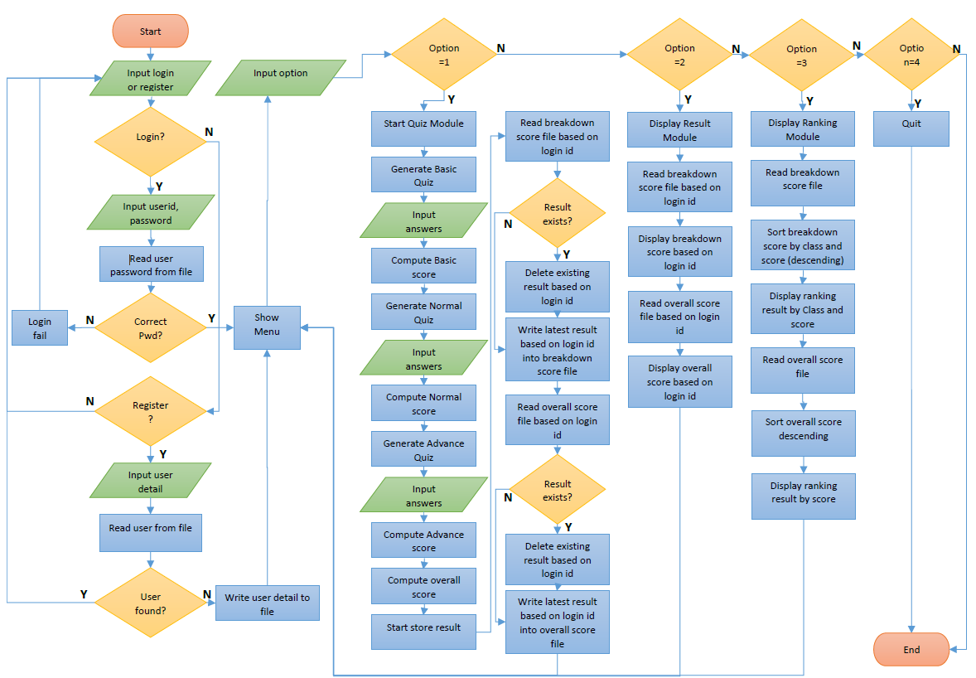

Refer to this file for the original file of the Flow Chart.



# 

# User Guide

1. **Login or Register**

**Register**

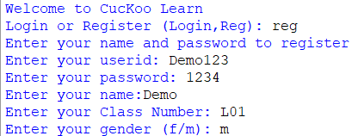

New users need to register and create a new account.

New users are required to enter their user id, password, name, class number, and gender.

**Login**

Users are required to enter their own user id and password,

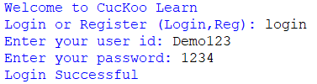

1. **Menu**

A menu will be displayed.

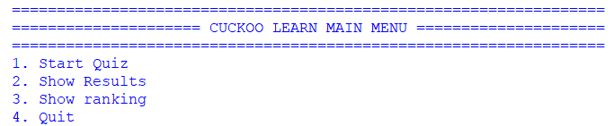

Users will have 4 options to choose from.

1. Start Quiz
2. Show Results
3. Show ranking
4. Quit
5. **Start the quiz**

A quiz menu will then be displayed.

The user has to decide if they want to proceed with the quiz.

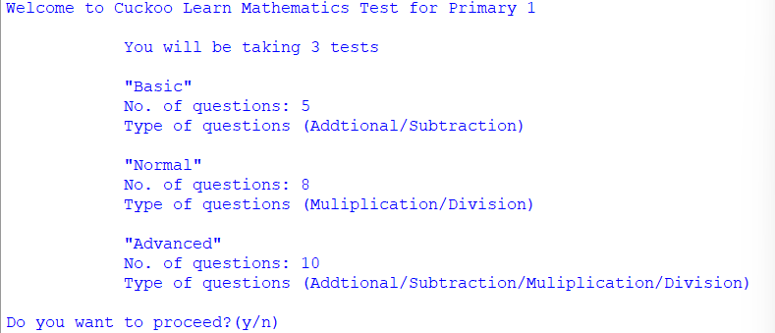

If the user had decided to proceed with the quiz, the question will be displayed and users have to input their answers. After the test, the program will show the user the amount of percentage correctness for all 3 quizzes.

1. **Show Results**

The 3 different types of quiz results will be displayed respectively. It will state the number of correct questions the user has answered and the percentage of correct answers for each question.

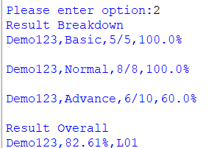

1. **Show ranking**

The program will show the ranking for individual classes and the overall ranking.

